Information and Computing Technologies and Programming



Department of Electronics Engineering

School of Engineering and Architecture

Holy Angel University

Submitted by:

Rivera, Jem Christine Q.

Group 1/ EC-502 / Thursday, 10:20AM – 1:20PM

Submitted to:

Engr. Edgar S. Macasaquit

July 5, 2018

Activity 1

Data and Results

Raspberry Pi is a credit-card-sized computer that can be used in different electronics projects and is capable of running software applications such as spreadsheets, word processing, and internet browser.

In order to maximize the use of Raspberry Pi, an operating system must first be installed. An SD card will be used as its booting drive, which should contain the New Out of Box Software (NOOBS) downloaded files. Once the SD card is inserted in the Raspberry Pi and the necessary cables are plugged in, the Raspberry Pi will start booting. A list of all the possible operating software will appear. In our case, we chose to install Raspbian as recommended by our professor. It would take a while to install, so patience is also a necessity. A desktop graphical user interface (GUI) will appear after the installation is completed. It will then be ready for multiple applications.

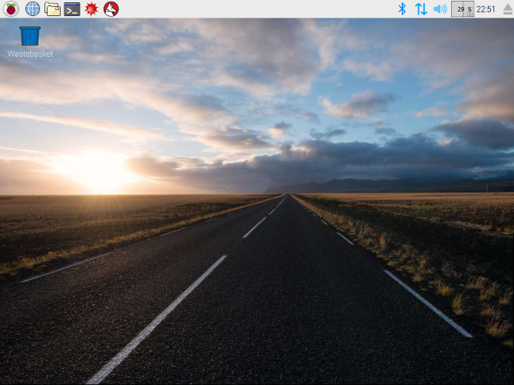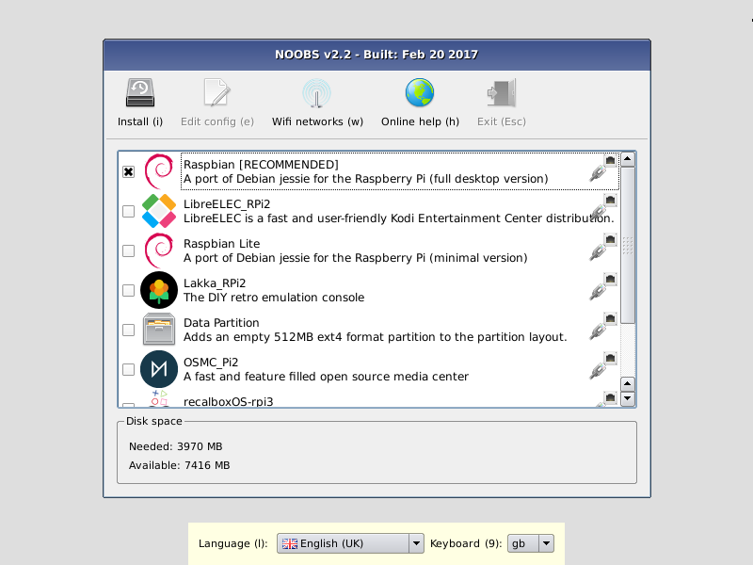

Answer to Questions

1. Discuss methods of installing OS in Raspberry Pi

In installing an operating system in raspberry pi, an SD card with a minimum of 8GB storage capacity is required. The SD card should be formatted before copying the necessary files that will be used for the installation. Once the SD card has been formatted, copy the extracted NOOBS files on the root directory of the SD card. Safely remove the SD card, then insert it in the raspberry pi. Plug in the keyboard, mouse, monitor cables, and power cables into the raspberry pi. After the booting process of the Raspberry Pi, a window will appear with a list of the different operating systems that can be installed. Select raspbian from the list, it will then run through its installation process. Once the installation has been completed, the GUI of the desktop will appear.

2. What are the applications of Raspberry pi?

Some applications of Raspberry Pi are: Media Center, Desktop PC, Wireless Print Server, and Retro Gaming Machine.

Conclusion:

Through this activity, we have learned and experienced the process involved in the installation of an operating system in Raspberry Pi. We have learned that the operating system used, Raspbian, is a Debian-based system and is widely based on Linux. Raspberry Pi can be applied in different projects such as Media Centers, Desktop PC, Wireless Print Server, and Retro Gaming Machine.

Activity 2

Data and Results

Remote access refers to the ability to access a computer, such as a home computer or an office network computer, from a remote location. In this experiment, we tried two different remote access connections, GUI-based and CLI-based remote access.

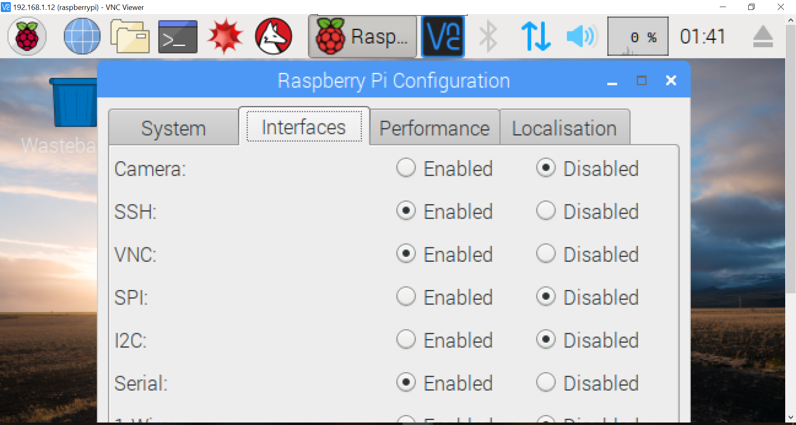Before dealing with the remote connection software itself, it is necessary to configure the Raspberry Pi. Under Preferences, in the Interfaces tab, the SSH and VNC should first be enabled.

It is then of importance that the IP address is set to static, in order to do so, open the Terminal, then type the command *sudo nano /etc/dhcpcd.conf*. It will open the configuration file *dhcpcd.conf* which contain commented commands for static IP address. The lines *interface eth0*, *static ip address*, and *static routers* should be uncommented to be able to set the IP address to 192.168.1.14, which was the assigned IP address for our group. To save the configuration file, hit Ctrl + X to exit then save. After saving the configuration file, we tried checking whether the IP address was already set by typing the command *ifconfig*, but it still doesn’t show the IP address that we’ve set. With the help of our professor, we learned that we should either restart our Raspberry Pi or reset its network for the configuration file to take effect. The easier way was to reset the network, the command used was *ip link set eth0 down* then *sudo ip link set eth0 up*.

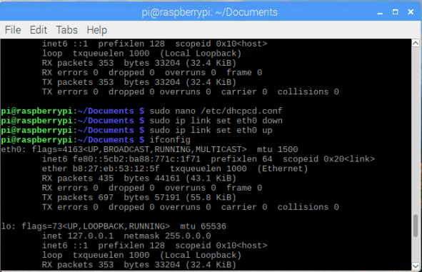

After verifying the IP address of the Raspberry Pi, a LAN cable is connected to the laptop. The IP address of the laptop should also be configured with the same network address as the Raspberry Pi for successful connection. It is then pinged on the laptop to verify the connection.

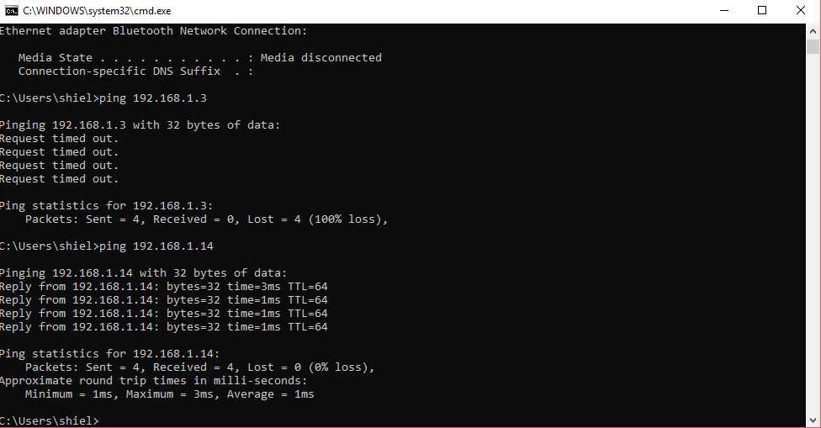

Then, open the VNC Viewer software and type in the IP address of the Raspberry Pi to set up a connection. When a login window appears, enter *pi* as the username and *raspberry* for the password. The exact interface of the Raspberry Pi will then appear on your laptop.

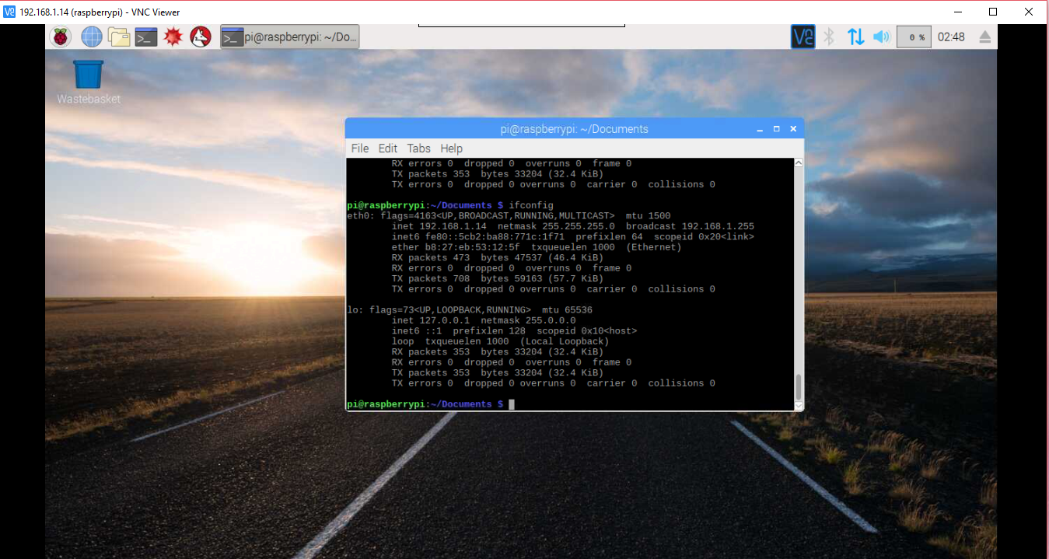

Another remote access is through the use of SSH in PuTTY. Open the PuTTY software and enter the IP address of the Raspberry Pi as the Host Name, select SSH, and select Open.

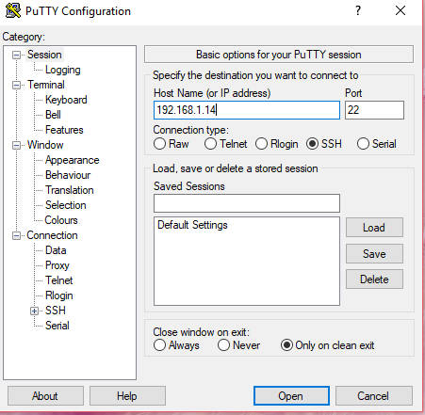

A command line interface will then appear asking for the login username and password, enter the default login configuration which is *pi* for the username and *raspberry* for the password. It will then contain the same configurations as that of the Raspberry Pi.

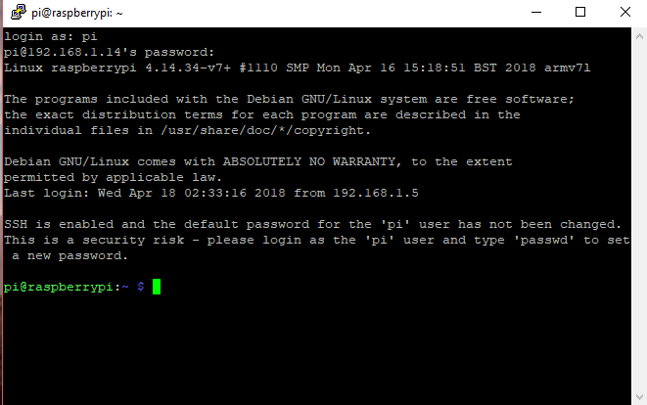

Answer to Questions

1. Discuss different ways of connecting to Raspberry Pi

There are multiple ways of connecting to a Raspberry Pi, some are through the direct connection of HDMI to TV, HDMI to VGA to PC Monitor, and Analogue to TV. Another way is through a LAN cable, it can connect the Raspberry Pi to a PC with the use of Remote Connection, specifically, through VNC software.

2. Compare GUI based Remote Access with CLI

In a Graphical User Interface (GUI) based remote access, a graphical interface and icons can be seen which the users can easily interact with. While in a Command Line Interface (CLI), it only uses text-based representations wherein the user can only type the commands necessary to operate specific software or devices.

Conclusion

In this experiment, we were taught about the basics in connecting a Raspberry Pi. Initially, to be able to install an operating system inside the Raspberry Pi, it is necessary to connect it to an LCD monitor using an HDMI to VGA connector. After it was installed, we learned about the basic commands necessary in using the Linux-based operating system, Raspbian. These commands for changing the IP address and status of the network were also necessary when trying out remote access. We used the VNC Viewer software and PuTTY to remotely access the Raspberry Pi using our laptop, it requires a connection of Raspberry Pi to the laptop via LAN cable and a static IP address to be properly connected. A VNC Viewer uses GUI to interact with the users while PuTTY uses text-based representation or CLI.